TESTIMONY BEFORE THE
NORTH DAKOTA SENATE APPROPRIATIONS COMMITTEE
BY
THEODORE ROOSEVELT REPRESSWAY ASSOCIATION
CAL KLEWIN, EXECUTIVE DIRECTOR
JANUARY 9, 2017

Chairman Holmberg,
Members of the Senate Appropriations Committee

Good morning. I am Cal Klewin, Executive Director of the Theodore Roosevelt Expressway Association (TREA).

The Theodore Roosevelt Expressway (Highway 85) is a Federally-Designated High Priority Corridor on the National Highway System. It runs from Rapid City, SD, to Canada through western North Dakota to the Port of Raymond in Montana. On the southern end, it connects to the Heartland Expressway, which connects Rapid City, SD, to Denver, CO. The Heartland Expressway then links to the Ports-to-Plains Trade Corridor, which connects Denver, CO, to Laredo, TX. These three corridors are collectively known as the Ports-to-Plains Alliance.

The Theodore Roosevelt Expressway Association wishes to recognize the significant investment made in western North Dakota by the commitment of General Fund dollars that came from oil and natural gas revenues. The completion of the expansion of U.S. Highway 85 between Williston and Watford City certainly improved the safety and efficiency of the Theodore Roosevelt Expressway. The next steps are underway as the Environmental Impact Study for US Highway 85 Project from the I-94 Interchange to the Watford City Bypass (McKenzie County Road 30) continues.

In December, 2016 in the State of Freight II: Implementing the FAST Act and Beyond, published by American Association of State Highway and Transportation Officials (AASHTO) and the American Association of Port Authorities (AAPA), the Theodore Roosevelt Expressway was highlighted in a section titled: Interior State Freight Connectivity: Connecting the Heartland with Our Ports and the World.

Along with providing freight connectivity for manufacturing and agriculture in rural regions of the country, the economy is experiencing growth in the domestic energy sector. In 2014, energy commodities accounted for 54.2 percent of the 1.4 billion short tons of foreign trade cargo handled at U.S. ports and which is moving through our interior states. These energy commodities move almost exclusively in chartered vessels and are unaffected by the international carrier alliances. Last year Congress lifted a 40-year ban on exporting crude oil. While it is too early to forecast what the national impact will on our economy, the increased energy production has already been felt on the freight network in states like North Dakota.

Further the State of Freight II described the situation along U.S. Highway 85 in North Dakota as Improvement Through Partnering in North Dakota.

In 2014, the North Dakota Highway Patrol reported oversized truck permits issued for U.S. Highway 85 averaged 200 a day exceeding more than 72,000 overwidth, overheight and/or overweight vehicles on the road. Non-truck traffic averaged 20,900 per day north and south of the Long X Bridge. Traffic increased due to oil and gas development and agriculture production. From 2006-2012, vehicle traffic jumped 454 percent and truck traffic increased 565 percent. All of the growth has been accommodated on a rural two-lane highway.

While the data is a bit dated in that publication, it is important to note that U.S. 85 through 2016 still experiences significantly more truck permitted loads that alternative north-south corridors in North Dakota.

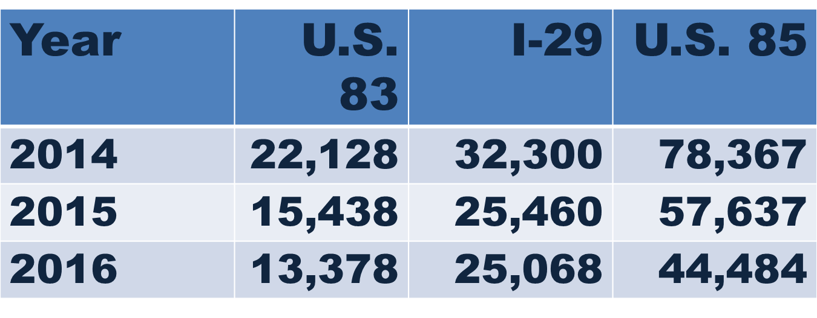
Additionally, while energy production is down, signs are strong that energy companies are hiring and that the oil and gas industry will be expanding in the future.

This is not the time to lessen consideration of future improvements in western North Dakota. As the AASHTO/AAPA publication pointed out and the permitted load data still indicates, U.S. Highway 85 continues to be an important freight corridor. The FAST Act and its focus on freight movement provide an opportunity for North Dakota in both formula and discretionary funds. As the new federal administration moves forward, infrastructure investment is at the forefront. North Dakota and partners like the Theodore Roosevelt Expressway Association and the Ports-to-Plains Alliance must certainly be a voice for rural America that new opportunities for infrastructure must not be limited to private dollars requiring a payback through tolling.

I know this Committee is fully aware of the immediate transportation infrastructure needs in our state. The Theodore Roosevelt Expressway Association supports long term sustainable state transportation funding for NDDOT.
That concludes my testimony, I will try to answer any questions you may have.
Thank you.

