Greetings:
Things are moving forward on the Theodore Roosevelt Expressway in North Dakota!!
The Final Environmental Impact Statement is complete for the project from Watford City to I-94 at Belfield North Dakota. We now need to Identify and secure funding to start the construction phase.
The replacement of the Long X Bridge will begin in Mid-Summer of 2019! The funding is in place for this project, Thanks to the North Dakota Legislature. (Explanation summary of the FEIS and Long X replacement projects are below).
The North Dakota Department of Transportation (NDDOT) has submitted two Federal Funding Grant applications for the Theodore Roosevelt Expressway, an INFRA Grant summitted earlier this year and most recently BUILD. (Grant Explanations below)
BUILD stands for (Better Utilizing Investments to Leverage Development) and has a maximum request of $25M and NDDOT is putting the Theodore Roosevelt Expressway Freight Expansion Project in at that amount. The award notices of winning projects are required to be made no later than November 12, 2019.
INFRA stands for (INfrastructure For Rebuilding America) and NDDOT has requested $40M to complete the Theodore Roosevelt Expressway Freight Expansion Project. There is no listed deadline on INFRA as to when they’ll announce winners, but we anticipate hearing around the time we hear about BUILD.
Thank you to all that have submitted support letters to the NDDOT in support of the Theodore Roosevelt Expressway.
North Dakota Senate SB2268, Corridors of Commerce.
The bill provides funding from the Bank of North Dakota using a bonding mechanism for NDDOT projects. The Corridor of Commerce bill has passed the North Dakota Legislature and the above-mentioned grants if successful will allow the NDDOT to access the Bank of North Dakota loan program for the construction of projects that fit the criteria of set out by the Corridors of Commerce Bill.
Thank you to Senator Dale Patton sponsor and carrier of this legislation.

Belfield NDStreet Project Moving Forward
- The project was part of the NDSTREET grant program which is administered by the NDDOT. City of Belfield was awarded the grant for the improvements of intersections from Highway 10, north to the south intersection of I-94.
- The project originally included just the installation of turn lanes, but has since added the extension of the shared use path and a pedestrian crossing on highway 85.
  - Note: the DOT was scheduled to chip seal through Belfield this summer on a separate project. Knowing this project would tear up the recent chip seal, they will stop short of this project and the chip seal will be added to this project after paving.
- The NDSTREET application cost estimate is $1,992,600.00; with a cost breakdown of 80.93% Federal, 9.07% State and 10% Local
- Project Status:
- Field Review has been completed.
- Solicitation of Views to Local, State and Federal Agencies have been sent out.
- Public Input Meeting was held on June 4th, 2019
- Wetland Delineations will be completed by mid-June
- Cultural Resources will be completed by mid-June
- Final Plans will be completed in December
- Tentative Bid date is scheduled for February, 2020
- Construction is scheduled for Summer of 2020

Final Environmental Impact Statement (FEIS) and Record of Decision (ROD)
The US Highway 85 Project encompasses approximately 62 miles of roadway in Stark, Billings, and McKenzie counties, North Dakota. The project begins at the Interstate 94 (I-94) interchange and extends north to the Watford City Bypass (McKenzie County Road 30). The proposed action is to expand this segment of US Highway 85 from a two-lane highway to a four-lane highway with flexible design options to avoid or minimize impacts and rehabilitate or replace the historic Long X Bridge over the Little Missouri River. The goal of the project is to essentially maintain and follow the existing US Highway 85 alignment, utilizing the existing infrastructure to minimize potential impacts on environmental, socioeconomic, and human-made resources, to the maximum extent practicable.
Project Map below
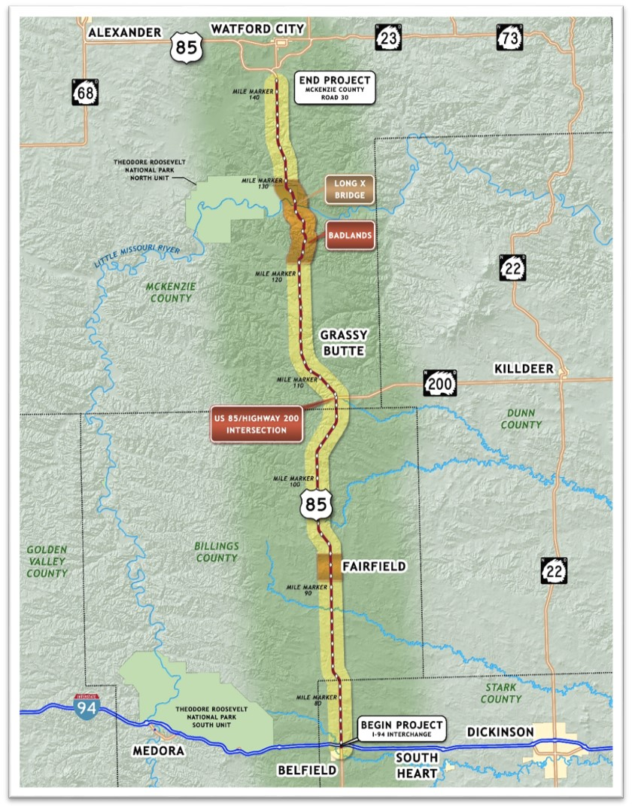
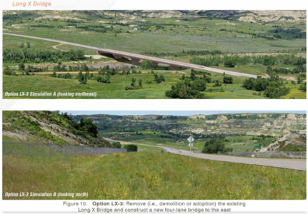
Long X Bridge Contract Awarded
Replacement to be Open by July 2021
This historic Long X Bridge on US Highway 85 south of Watford City will soon be replaced with a new bridge. Work on the new Little Missouri River crossing is scheduled for completion in July 2021.
The ND Department of Transportation awarded the bid to Ames Construction to build the new bridge and dismantle the old one. Ames, based in Burnsville, MN, was the only bidder on the project. Its $33,971,510 bid was more than $6 million over the engineer’s estimate.
The company will begin mobilizing on the site in July and work is expected to begin in August, according to Bill Gathman, assistant district engineer for DOT’s Williston District. Gathman said the next step in getting the project started will be a pre-construction conference.
Replacing the old truss bridge with a newer design will allow it to better accommodate oversize truck traffic. It’s vertical clearance is just over 16 feet, so it’s no surprise as Gathman says that “it’s been hit a few times in the last few years.”
The new bridge, to be built east of the current structure, will be four lanes wide in anticipation of future construction that will widen other segments of Highway 85 between Watford City and Belfield.
Because the Long X Bridge is eligible for listing on the National Register of Historic Places, federal law requires it be made available for adoption prior to its removal. Emmons County rancher Paul Silbernagel will do that with the southern span of the bridge, which is about 250 feet in length. Silbernagel plans to reassemble it on his ranch east of Linton where it will span Beaver Creek. The bridge will be on private property, but it should be visible from Highway 13.

Oversized Permitted Loads

I will update as soon as soon as I receive the second quarter information from the N.D. Highway Patrol and the end of the 2nd quarter.
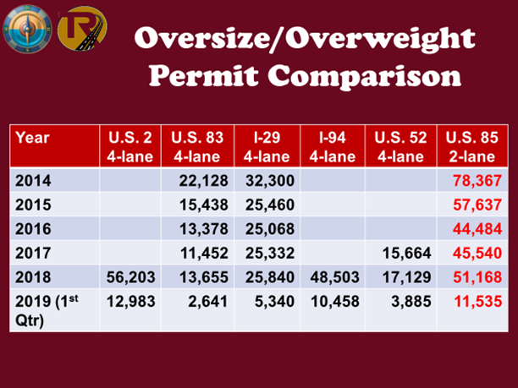

Mark your Calendar for the Ports to Plains Annual meeting to be held in Williston N.D. on October 15 -17 2019. Watch for more information on this Transportation Conference it looks like it is shaping up to be a good one.
If you or an organization you are aware of would like to have an update or presentation of the TREA progress and Ports-to-Plains activities, please contact us and we will do our best to accommodate.

Cal Klewin
Executive Director
Theodore Roosevelt Expressway Association.
701.523.6171 cal@trexpressway.com

