PO Box 1306 .
Williston, ND 58802-1306
701.523.6171
cal@trexpressway.com . www.trexpressway.com

Summer Update

Greetings from the Theodore Roosevelt Expressway Association and we hope your summer has so far provided opportunity for time spent with family, friends and some fun.
Public hearings and comment period for the Theodore Roosevelt Expressway (TRE) U.S. 85 from Watford City N.D. to I-94 at Belfield N.D. for the Draft Environmental Impact Statement (DEIS) ended on June 25, 2018. The hearings were held in Belfield, Fairfield, and Watford City, North Dakota. There were between 60-70 comment letters regarding the project, the comments ranged from support of the overall project, to support of the replacement of the Long X Bridge, and concerns over expanding the highway within the Badlands and Theodore Roosevelt National Park.
The Team will be working on these comments from both members of the public and agencies, as well as putting together the Final Environmental Impact Statement/Record of Decision. The total estimated cost of the entire project (all 62 miles) is approximately $500 million. The Long X Bridge replacement is the only segment that has funds allocated. The 2018-2021 Statewide Transportation Investment Program (STIP) has designated $50 million. The current cost estimate is approximately $36 million. The project will be advertised for bids after completion of the environmental document.
The City of Belfield’s Project for Highway 85 has been selected for funding as part of the NDDOT Small Town Revitalization Endeavor for Enhancing Transpiration Grant with construction to begin 2020. This grant of approximately ($1,800,000.00 to fund eligible items) will assist the community address the traffic and freight volume the community is facing now and in the future.
Theodore Roosevelt Expressway Association (TREA) along with the Ports to Plains Alliance and Stark Development submitted letters of support to the North Dakota Department of Transportation for the Highway Renovation Grant to assist with the volume of traffic and freight that moves through community of Belfield.
We continue to lobby for Transportation funding for the Theodore Roosevelt Expressway Corridor at the federal, state and local levels and most recently met with officials from the North Dakota Department of Transportation and Governor Burgum’s office discussing legislation for the 2019 North Dakota Legislative session.

Below are the most recent oversized load comparisons (thru June 2018) keep in mind the comparison are four lane highways and U .S 85 (Theodore Roosevelt Expressway) is two lane except for the new portion between Watford City and Williston North Dakota

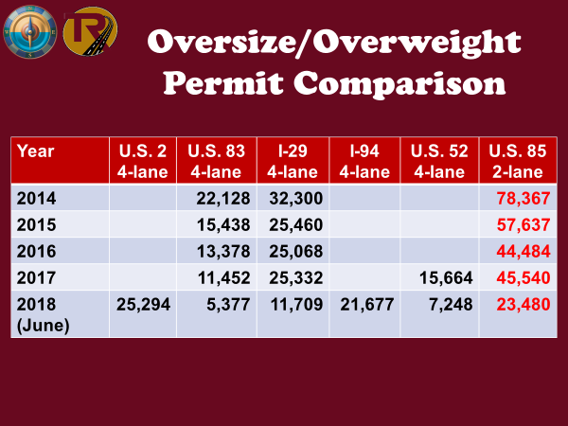

If you or an organization you are aware of, that would like to have an update or presentation of the TREA progress and Ports to Plains activities please contact us and we will do our best to accommodate.

Cal Klewin
Executive Director
Theodore Roosevelt Expressway Association.
701.523.6171
cal@trexpressway.com

